Nama : Andri Firman Saputra  
NIM : 201011402125  
Kelas : 02TPLP023  
Tugas : Algoritma II – Pertemuan 13

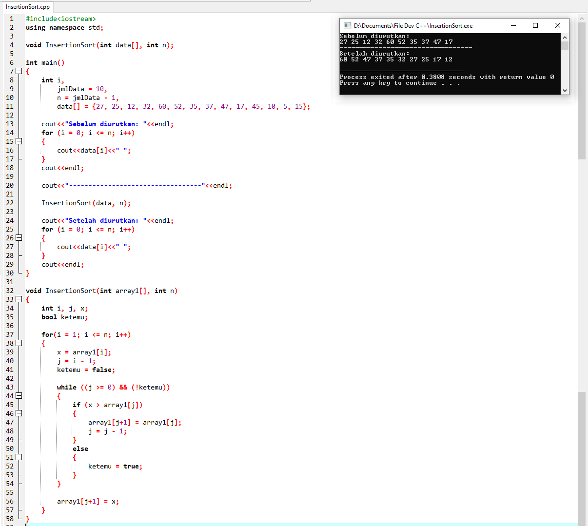

**Source Code:**

#include<iostream>

using namespace std;

void InsertionSort(int data[], int n);

int main()

{

int i,

jmlData = 10,

n = jmlData - 1,

data[] = {27, 25, 12, 32, 60, 52, 35, 37, 47, 17, 45, 10, 5, 15};

cout<<"Sebelum diurutkan: "<<endl;

for (i = 0; i <= n; i++)

{

cout<<data[i]<<" ";

}

cout<<endl;

cout<<"----------------------------------"<<endl;

InsertionSort(data, n);

cout<<"Setelah diurutkan: "<<endl;

for (i = 0; i <= n; i++)

{

cout<<data[i]<<" ";

}

cout<<endl;

}

void InsertionSort(int array1[], int n)

{

int i, j, x;

bool ketemu;

for(i = 1; i <= n; i++)

{

x = array1[i];

j = i - 1;

ketemu = false;

while ((j >= 0) && (!ketemu))

{

if (x > array1[j])

{

array1[j+1] = array1[j];

j = j - 1;

}

else

{

ketemu = true;

}

}

array1[j+1] = x;

}

}

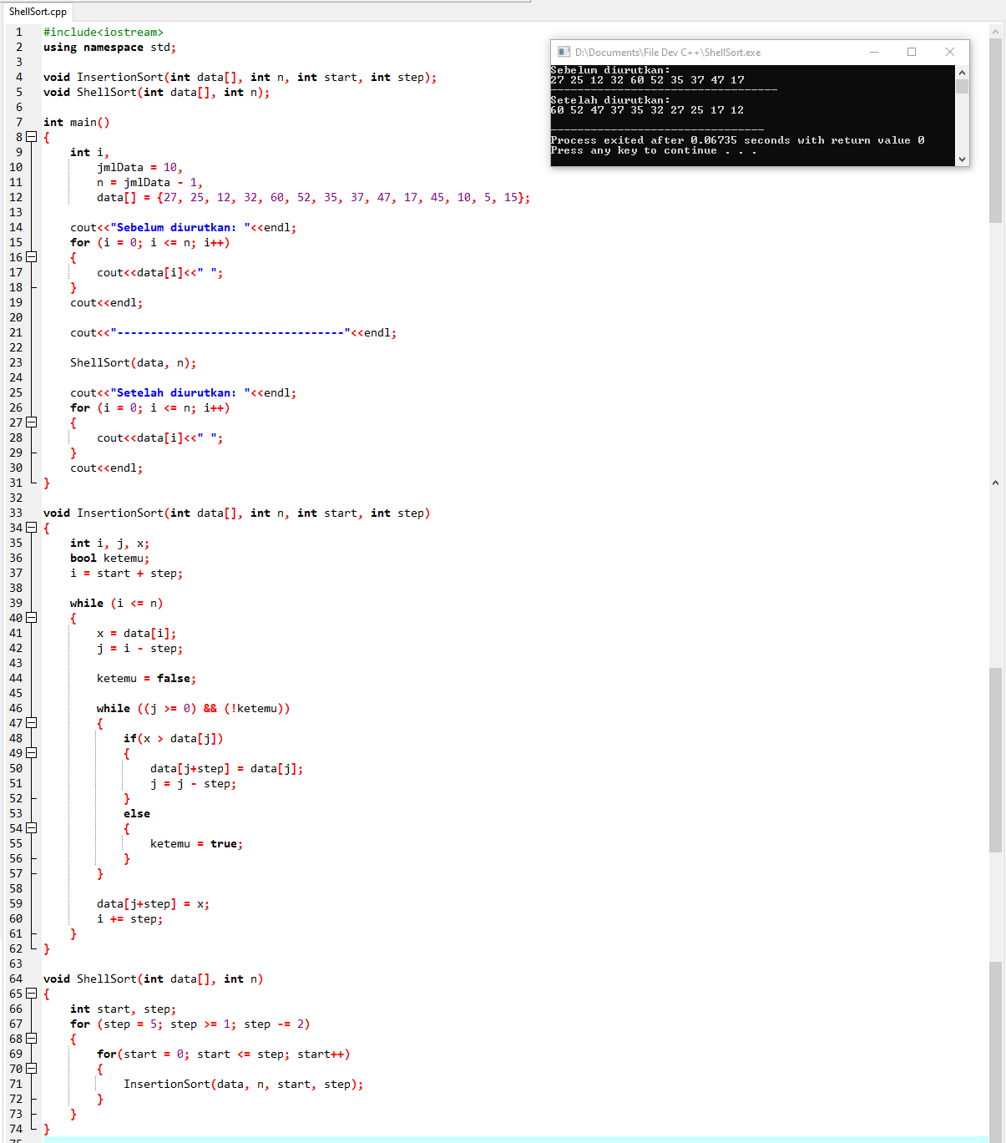

**Source Code:**

#include<iostream>

using namespace std;

void InsertionSort(int data[], int n, int start, int step);

void ShellSort(int data[], int n);

int main()

{

int i,

jmlData = 10,

n = jmlData - 1,

data[] = {27, 25, 12, 32, 60, 52, 35, 37, 47, 17, 45, 10, 5, 15};

cout<<"Sebelum diurutkan: "<<endl;

for (i = 0; i <= n; i++)

{

cout<<data[i]<<" ";

}

cout<<endl;

cout<<"----------------------------------"<<endl;

ShellSort(data, n);

cout<<"Setelah diurutkan: "<<endl;

for (i = 0; i <= n; i++)

{

cout<<data[i]<<" ";

}

cout<<endl;

}

void InsertionSort(int data[], int n, int start, int step)

{

int i, j, x;

bool ketemu;

i = start + step;

while (i <= n)

{

x = data[i];

j = i - step;

ketemu = false;

while ((j >= 0) && (!ketemu))

{

if(x > data[j])

{

data[j+step] = data[j];

j = j - step;

}

else

{

ketemu = true;

}

}

data[j+step] = x;

i += step;

}

}

void ShellSort(int data[], int n)

{

int start, step;

for (step = 5; step >= 1; step -= 2)

{

for(start = 0; start <= step; start++)

{

InsertionSort(data, n, start, step);

}

}

}